WEB DEVELOPMENT INTERNSHIP REPORT

TRIBUTE TO S.P. BALASUBRAHMANYAM

DONE BY-

DEKSHITHA RAVIKUMAR

1KS18CS075

K.S. INSTITUTE OF TECHNOLOGY

**ACKNOWLEDGEMENT**

The satisfaction and euphoria that accompany the successful completion of any task will be incomplete without the mention of the individuals, we are greatly indebted to, who through guidance and providing facilities have served as a beacon of light and crowned our efforts with success.

I, Dekshitha (Usn-1KS18CS075) would like to take this opportunity to express my sincere gratitude to the organisation for providing this Internship program.

I would like to thank Mr. Nithin for training and also for his valuable guidance and support in order to finish this project.

I extend my gratitude and regards to everyone who helped me during my internship. It was a great experience.

**TABLE OF CONTENTS**

|  |  |  |
| --- | --- | --- |
| S.No. | Particulars | Page No. |
| 1 | Project Overview | 4-5 |
| 2 | Requirements Specification | 6 |
| 3 | Webpage Details | 7 |
| 4 | Code | 8-32 |
| 5 | Snapshots | 33 |
| 6 | Learning and Problems Faced | 34 |

**PROJECT OVERVIEW**

This project was aimed at building a webpage as a tribute to S.P. Balasubrahmanyam.

The basic aim of the project is to build a webpage using technologies such as HTML and CSS. It was required to include the image and the name at the top and a layout for the rest of the details such as the most, list of awards won, and other information at the bottom. The website consists of paragraphs, lists, images with CSS to give it a decent look.

Technologies used-

* HTML5

HTML5 is a markup language used for structuring and presenting content on the World Wide Web. It is the fifth and current major version of the HTML standard.

It was published in October 2014 by the World Wide Web Consortium (W3C) to improve the language with support for the latest multimedia, while keeping it both easily readable by humans and consistently understood by computers and devices such as web browsers, parsers, etc.

HTML5 includes detailed processing models to encourage more interoperable implementations; it extends, improves and rationalizes the markup available for documents, and introduces markup and application programming interfaces (APIs) for complex web applications.

* CSS

Cascading Style Sheets (CSS) is a style sheet language used for describing the presentation of a document written in a markup language like HTML. CSS is a cornerstone technology of the World Wide Web, alongside HTML and JavaScript.

CSS was first proposed by Hakon Wium Lie on October 10, 1994.

Style sheets have existed in one form or another since the beginnings of Standard Generalized Markup Language (SGML) in the 1980s, and CSS was developed to provide style sheets for the web. One requirement for a web style sheet language was for style sheets to come from different sources on the web. Therefore, existing style sheet languages like DSSSL and FOSI were not suitable. CSS, on the other hand, let a document's style be influenced by multiple style sheets by way of "cascading" styles.

CSS is designed to enable the separation of presentation and content, including layout, colors, and fonts. This separation can improve content accessibility, provide more flexibility and control in the specification of presentation characteristics, enable multiple web pages to share formatting by specifying the relevant CSS in a separate .css file, and reduce complexity and repetition in the structural content.

**REQUIREMENTS SPECIFICATION**

Tools that are needed-

For good performance, atleast Pentium 200-MHz computer with a minimum of 64 MB of RAM (or 128 MB of RAM) is recommended.

Software required-

* Web Browser (Google Chrome-stable)
* Text editor (VS code)

**WEBPAGE DETAILS**

This webpage is build as a tribute to S.P.B – was an Indian musican, playback singer, television anchoer, music director, actor, dubbing artist and film producer who worked predominantly in Telugu, Tamil, Kannada, Hindi and Malayalam films.

This webpage has navigation bar at the top to move across different sections of the page. The home page has, name and a picture of him. Below this section, there is a layout for the other sections. The different sections that are included are-

* ‘About’ gives brief description about him, his life, career and achievements.
* ‘Famous songs’ contains 3 main tables to list out the popular songs in Tamil, telugu and Kannada respectively. These tables also contain links for the listed songs.
* ‘Awards’ lists out the various awards which S.P.B. was entitled with.
* ‘Tribute’ contains a small video.

At the end, the webpage has links to the official social media pages of S.P.B.

**CODE**

* HTML

<!DOCTYPE html>

<html>

<head>

<meta charset="UTF-8">

<meta name="viewport" content="width=device-width, initial-scale=1.0">

<title>S.P.B</title>

<link rel="stylesheet" href="https://stackpath.bootstrapcdn.com/font-awesome/4.7.0/css/font-awesome.min.css">

<link rel="stylesheet" type="text/css" href="style.css">

<link rel="preconnect" href="https://fonts.gstatic.com">

<link href="https://fonts.googleapis.com/css2?family=Poppins:ital,wght@1,300&display=swap" rel="stylesheet">

<link rel="preconnect" href="https://fonts.gstatic.com">

<link rel="preconnect" href="https://fonts.gstatic.com">

<link rel="preconnect" href="https://fonts.gstatic.com">

<link rel="preconnect" href="https://fonts.gstatic.com">

<link href="https://fonts.googleapis.com/css2?family=Lora:ital@0;1&display=swap" rel="stylesheet">

<link rel="stylesheet" href="https://cdnjs.cloudflare.com/ajax/libs/font-awesome/4.7.0/css/font-awesome.min.css">

</head>

<body>

<header>

<ul class="nav" style="background-color: black;">

<li class="active"><a href="#start" style="text-decoration: none; color: rgb(47, 89, 228); font-family: 'Lora', serif;">Home</a></li>

<li><a href="#about" style="text-decoration: none; color: rgb(47, 89, 228); font-family: 'Lora', serif;;">About</a></li>

<li><a href="#songs" style="text-decoration: none; color: rgb(47, 89, 228); font-family: 'Lora', serif;;">Songs</a></li>

<li><a href="#awards" style="text-decoration: none; color: rgb(47, 89, 228); font-family: 'Lora', serif;;">Awards</a></li>

<li><a href="#clip" style="text-decoration: none; color: rgb(47, 89, 228); font-family: 'Lora', serif;;">Tribute</a></li>

</ul>

</header>

<section class="start">

<div class="textBx">

<h2 style="text-align: center; color: white;">Sripathi Panditaradhyula Balasubrahmanyam</h2>

<h4 style="text-align: center; color: white;">Indian Musician</h3>

<q>Mesmerising tune of voice grind to a halt for good..</q>

<img src="pictures/spb.jpg">

</div>

</section>

<section class="about">

<div id="about" class="heading" >

<h2 style="color: rgb(47, 89, 228); font-family: 'Lora', serif;">About</h2>

</div>

<div class="content">

<div class="contentBx"><h4>(4 June 1946 - 25 September 2020)</h4>

<img src="pictures/abt.jpg" style="float: right; width: 500px; height: 512px; "/>

<p>S.P Balasubrahmanyam, S. P. B. or Balu, was a veteran Indian musician, playback singer, television anchor, music director, actor, dubbing artist, and film producer who worked predominantly in Telugu, Tamil, Kannada, Hindi, and Malayalam films.

Balasubrahmanyam has won six National Film Awards for Best Male Playback Singer for his works in four different languages – Telugu, Tamil, Kannada, and Hindi; 25 Andhra Pradesh state Nandi Awards for his work in Telugu cinema; and numerous other state awards from Karnataka and Tamil Nadu.

In addition, he won the Filmfare Award, and six Filmfare Awards South. According to some sources, he held the Guinness World Record for recording the highest number of songs by a singer with over 40,000 songs.

He recorded 21 songs in Kannada for the composer Upendra Kumar in Bengaluru from 9 am to 9 pm on 8 February 1981. In addition, he recorded 19 songs in Tamil and 16 songs in Hindi in a day, which has also been called a record. In 2012, he received the state NTR National Award for his contributions to Indian cinema.

In 2016, he was honoured with the Silver Peacock Medal as Indian Film Personality of the Year.He was a recipient of the Padma Shri (2001), Padma Bhushan (2011) and Padma Vibhushan (Posthumously) (2021) from the Government of India.

On 25 September 2020, S. P. Balasubrahmanyam died in Chennai after being hospitalized for over a month for complications due to COVID-19.

</p>

</div>

</div>

</section>

<section class="songs">

<div id="songs" class="heading" >

<h2 style="color: rgb(47, 89, 228); font-family: 'Lora', serif;">Famous songs</h2>

</div>

<div class="content1">

<p style="background: transparent; color: lightblue;">

S.P.B has recorded over 40,000 songs in a span of 50 years, which include film songs and devotional numbers recorded by various recording companies of the country. It is a world record which will be soon entering into the Guinness Book of World Records.

</p>

<div class="tableBx">

<table>

<caption>TAMIL</caption>

<tr>

<th>Sl No.</th>

<th>Title</th>

<th>Listen now</th>

</tr>

<tr>

<td>1</td>

<td>Vaa Vennila Unnaithane</td>

<td><a href="https://www.youtube.com/watch?v=9VMs5JITg5Q" target="_blank">click here</a></td>

</tr>

<tr>

<td>2</td>

<td>Sundari</td>

<td><a href="https://www.youtube.com/watch?v=8KAo6770hwk" target="_blank">click here</a></td>

</tr>

<tr>

<td>3</td>

<td>En Kadhale</td>

<td><a href="https://www.youtube.com/watch?v=u0CtfXRibAw"target="_blank">click here</a></td>

</tr>

<tr>

<td>4</td>

<td>Nalam Vazha</td>

<td><a href="https://www.youtube.com/watch?v=JjRs0KjYzbo"target="_blank">click here</a></td>

</tr>

<tr>

<td>5</td>

<td>Andhi Mazhai Pozhigirathu</td>

<td><a href="https://www.youtube.com/watch?v=sL8jk3olC1Q" target="_blank">click here</a></td>

</tr>

<tr>

<td>6</td>

<td>Kaadhal Rojave</td>

<td><a href="https://www.youtube.com/watch?v=Urr36-p9e5s" target="_blank">click here</a></td>

</tr>

<tr>

<td>7</td>

<td>Chumma Kizhi</td>

<td><a href="https://www.youtube.com/watch?v=w0nyEoXBEiA" target="_blank">click here</a></td>

</tr>

<tr>

<td>8</td>

<td>Kattu Kuyilu</td>

<td><a href="https://www.youtube.com/watch?v=fDaYAAiqXsM" target="_blank">click here</a></td>

</tr>

<tr>

<td>9</td>

<td>Anjali Anjali</td>

<td><a href="https://www.youtube.com/watch?v=1RmDri1Brc4" target="_blank">click here</a></td>

</tr>

<tr>

<td>10</td>

<td>Rakkamma</td>

<td><a href="https://www.youtube.com/watch?v=-J3Q7BCflw0" target="_blank">click here</a></td>

</tr>

</table>

<table>

<caption style="padding-bottom: 20px;">TELUGU</caption>

<tr>

<th>Sl No.</th>

<th>Title</th>

<th>Listen now</th>

</tr>

<tr>

<td>1</td>

<td>Papa Rita</td>

<td><a

href="https://www.youtube.com/watch?v=8A41KV-vLmA" target="_blank">click here</a></td>

</tr>

<tr>

<td>2</td>

<td>Anjali Anjali</td>

<td><a href="https://www.youtube.com/watch?v=YUIEft7ZN_Y" target="_blank">click here</a></td>

</tr>

<tr>

<td>3</td>

<td>Rajashekara</td>

<td><a href="https://www.youtube.com/watch?v=6yIKOlbYldo" target="_blank">click here</a></td>

</tr>

<tr>

<td>4</td>

<td>Yentha Yadigipoyavayya</td>

<td><a href="https://www.youtube.com/watch?v=3qly8pEDalE" target="_blank">click here</a></td>

</tr>

<tr>

<td>5</td>

<td>Suvvi Suvvi</td>

<td><a href="https://www.youtube.com/watch?v=RsuOontkJH4" target="_blank">click here</a></td>

</tr>

<tr>

<td>6</td>

<td>Eenade Edo</td>

<td><a href="https://www.youtube.com/watch?v=3d_m3BC4T2U" target="_blank">click here</a></td>

</tr>

<tr>

<td>7</td>

<td>Nilavade</td>

<td><a href="https://www.youtube.com/watch?v=6NmRLicLL84" target="_blank">click here</a></td>

</tr>

<tr>

<td>8</td>

<td>Jeevitame</td>

<td><a href="https://www.youtube.com/watch?v=mMNcTUZ1um4" target="_blank">click here</a></td>

</tr>

<tr>

<td>9</td>

<td>Niggadeesi Adugu</td>

<td><a href="https://www.youtube.com/watch?v=PQVsbtC4m04" target="_blank">click here</a></td>

</tr>

<tr>

<td>10</td>

<td>Paara Hushar</td>

<td><a href="https://www.youtube.com/watch?v=CbJaeel0Dro" target="_blank">click here</a></td>

</tr>

</table>

</table>

<table>

<caption style="padding-bottom: 20px;">KANNADA</caption>

<tr>

<th>Sl No.</th>

<th>Title</th>

<th>Listen now</th>

</tr>

<tr>

<td>1</td>

<td>Ee Nada Anda</td>

<td><a href="https://www.youtube.com/watch?v=n3eciFVxOto" target="_blank">click here</a></td>

</tr>

<tr>

<td>2</td>

<td>Naliva Gulabi Hoove</td>

<td><a href="https://www.youtube.com/watch?v=qrTvmCyGjvo" target="_blank">click here</a></td>

</tr>

<tr>

<td>3</td>

<td>Bhale Bhale Chandadha</td>

<td><a href="https://www.youtube.com/watch?v=y86bDv2khOY" target="_blank">click here</a></td>

</tr>

<tr>

<td>4</td>

<td>Kelisade Kallukallinali</td>

<td><a href="https://www.youtube.com/watch?v=90H_6howU14" target="_blank">click here</a></td>

</tr>

<tr>

<td>5</td>

<td>Ee Bhoomi Bannada Buguri</td>

<td><a href="https://www.youtube.com/watch?v=odSxFfPGlHk" target="_blank">click here</a></td>

</tr>

<tr>

<td>6</td>

<td>Geethanjali Pushpanjali</td>

<td><a href="https://www.youtube.com/watch?v=odSxFfPGlHk" target="_blank">click here</a></td>

</tr>

<tr>

<td>7</td>

<td>Bandalo bandalo</td>

<td><a href="https://www.youtube.com/watch?v=Qejeg5BDoWA" target="_blank">click here</a></td>

</tr>

<tr>

<td>8</td>

<td>O Kogile Naa</td>

<td><a href="https://www.youtube.com/watch?v=sxX0t7oautk" target="_blank">click here</a></td>

</tr>

<tr>

<td>9</td>

<td>Mutthu Mutthu Neera Haniya</td>

<td><a href="https://www.youtube.com/watch?v=48gGOYBPjoI" target="_blank">click here</a></td>

</tr>

<tr>

<td>10</td>

<td>Akashadinda Therinalli</td>

<td><a href="https://www.youtube.com/watch?v=RYyBxx6EXqw" target="_blank">click here</a></td>

</tr>

</table>

</div>

</div>

</section>

<section>

<div id="awards" class="heading" >

<h2 style="color: rgb(47, 89, 228); font-family: 'Lora', serif;">Awards</h2>

</div>

<div class="content2">

<div class="awardBx">

<img src="pictures/spb_2.webp" style="float: left; width: 700px; height: 463px; "/>

<p style="width: 100%; font-family: 'Poppins', sans-serif;">

S. P. Balasubrahmanyam has won several awards -

<ul style="background-color: lightskyblue; font-family:'Poppins', sans-serif;">

<ul>Filmfare Award in 1990</ul>

<ul>Filmfare Award - Telugu in 2007,

Filmfare Award - Tamil in 2008,

Filmfare Award - Kannada in 2011</ul>

<ul>National Award in 1996,

National Award in 1995,

National Award in 1988,

National Award in 1983,

National Award in 1981,

National Award in 1979</ul>

<ul>Filmfare Award South in 1987</ul>

<ul>Filmfare Award South in 1984</ul>

<ul>NTR National Award in 2012</ul>

<ul>Padma Shri in 2001</ul>

<ul>Padma Bhushan in 2011</ul>

</ul>

</p>

</div>

</div>

</section>

<section>

<div id="clip" class="clip">

<h2 style="color: rgb(47, 89, 228); font-family: 'Lora', serif;">Celebrating S.P.B - A Tribute</h2>

<video width="600" class="video" controls>

<source src="pictures/clip.mp4" type="video/mp4">

</video>

</div>

</section>

<section>

<div id="footer" class="footer">

<a href="https://facebook.com/SPB/" class="fa fa-facebook"></a>

<a href="https://twitter.com/spbalasubraman2?lang=en" class="fa fa-twitter"></a>

<a href="https://www.instagram.com/ispbofficial/?hl=en" class="fa fa-instagram"></a>

<a href="https://youtube.com/c/SPBalasubrahmanyamSpBaluofficial" class="fa fa-youtube"></a>

</div>

</section>

</body>

</html>

* CSS

*{

margin: 0;

padding: 0;

box-sizing: border-box;

}

body{

font-size: 26px;

background: url('blue-music.jpeg');

background-size: cover;

}

.nav{

border: 1px;

color: rgba(255, 255, 255, 0.877);

border-width:1px 0;

list-style: none;

margin: 0;

padding: 0;

text-align: center;

font-family: 'Lora', serif;

}

.nav li{

display: inline;

}

.nav a{

display: inline-block;

padding: 10px;

}

.nav li:hover{

background-color: skyblue;

color: black;

}

img{

display: block;

margin-left: auto;

margin-right: auto;

width: 1000px;

height: 700px;

}

h2{

font-family: 'Lora', serif;

padding-top: 25px ;

padding-bottom: 10px;

}

h4{

font-family: 'Lora', serif;

padding-bottom:15px ;

color: white;

}

p{

font-size: 21.5px;

background-color: lightskyblue;

width: 70%;

color: black;

text-align: left;

font-family: 'Poppins', sans-serif;

}

table{

width: 100%;

}

th{

color: white;

}

td{

text-align: center;

font-family: 'Poppins', sans-serif;

color: lightblue;

}

table,th,td{

border: 1px solid rgb(248, 248, 252);

border-collapse: collapse;

}

th,td{

padding: 5px;

}

caption{

color: white;

padding-bottom: 20px;

padding-top: 20px;

}

a{

text-decoration: none;

color: lightblue;

}

.footer{

padding-top: 50px;

text-align: center;

background-color: black;

}

.fa {

padding: 20px;

font-size: 30px;

width: 50px;

text-align: center;

text-decoration: none;

}

/* Add a hover effect if you want */

.fa:hover {

opacity: 0.7;

}

/* Set a specific color for each brand */

/* Facebook */

.fa-facebook {

background: #3B5998;

color: white;

align-content: center;

}

/* Twitter */

.fa-twitter {

background: #55ACEE;

color: white;

text-align: center;

}

.fa-instagram{

background:#3B5998;

color: white;

align-content: center;

}

.fa-youtube{

background: #55ACEE;

color: white;

}

q{

width: auto;

padding-left: 20%;

padding-bottom: 10vh ;

font-style:italic;

font-size: 6vh;

display: table;

color: rgb(45, 107, 241);

}

.video{

margin-left: auto;

margin-right: auto;

display: block;

padding-bottom: 10vh;

}

**SNAPSHOTS**

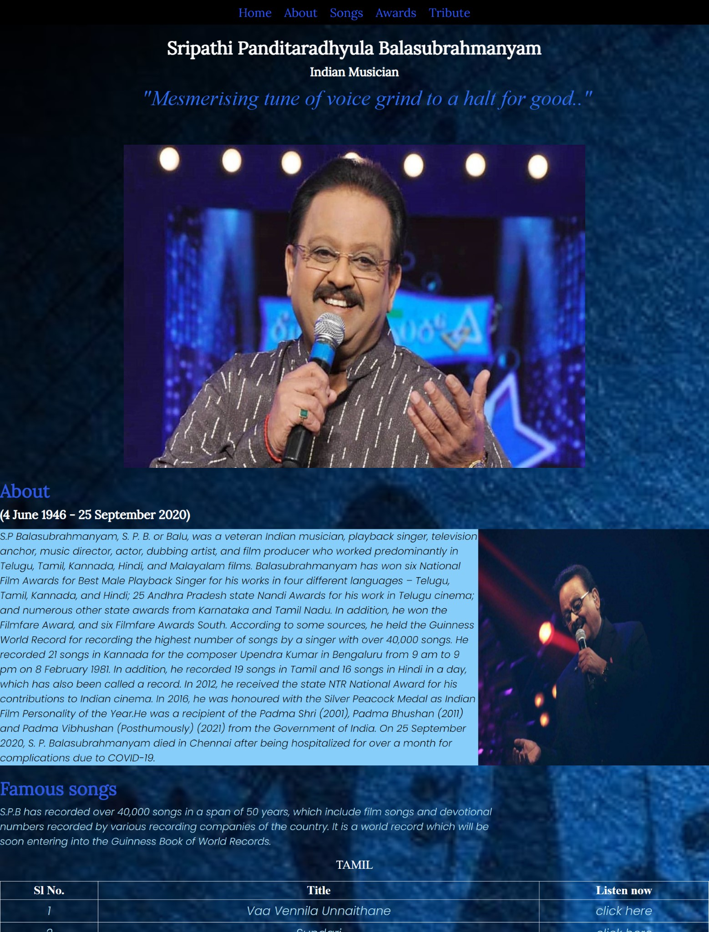

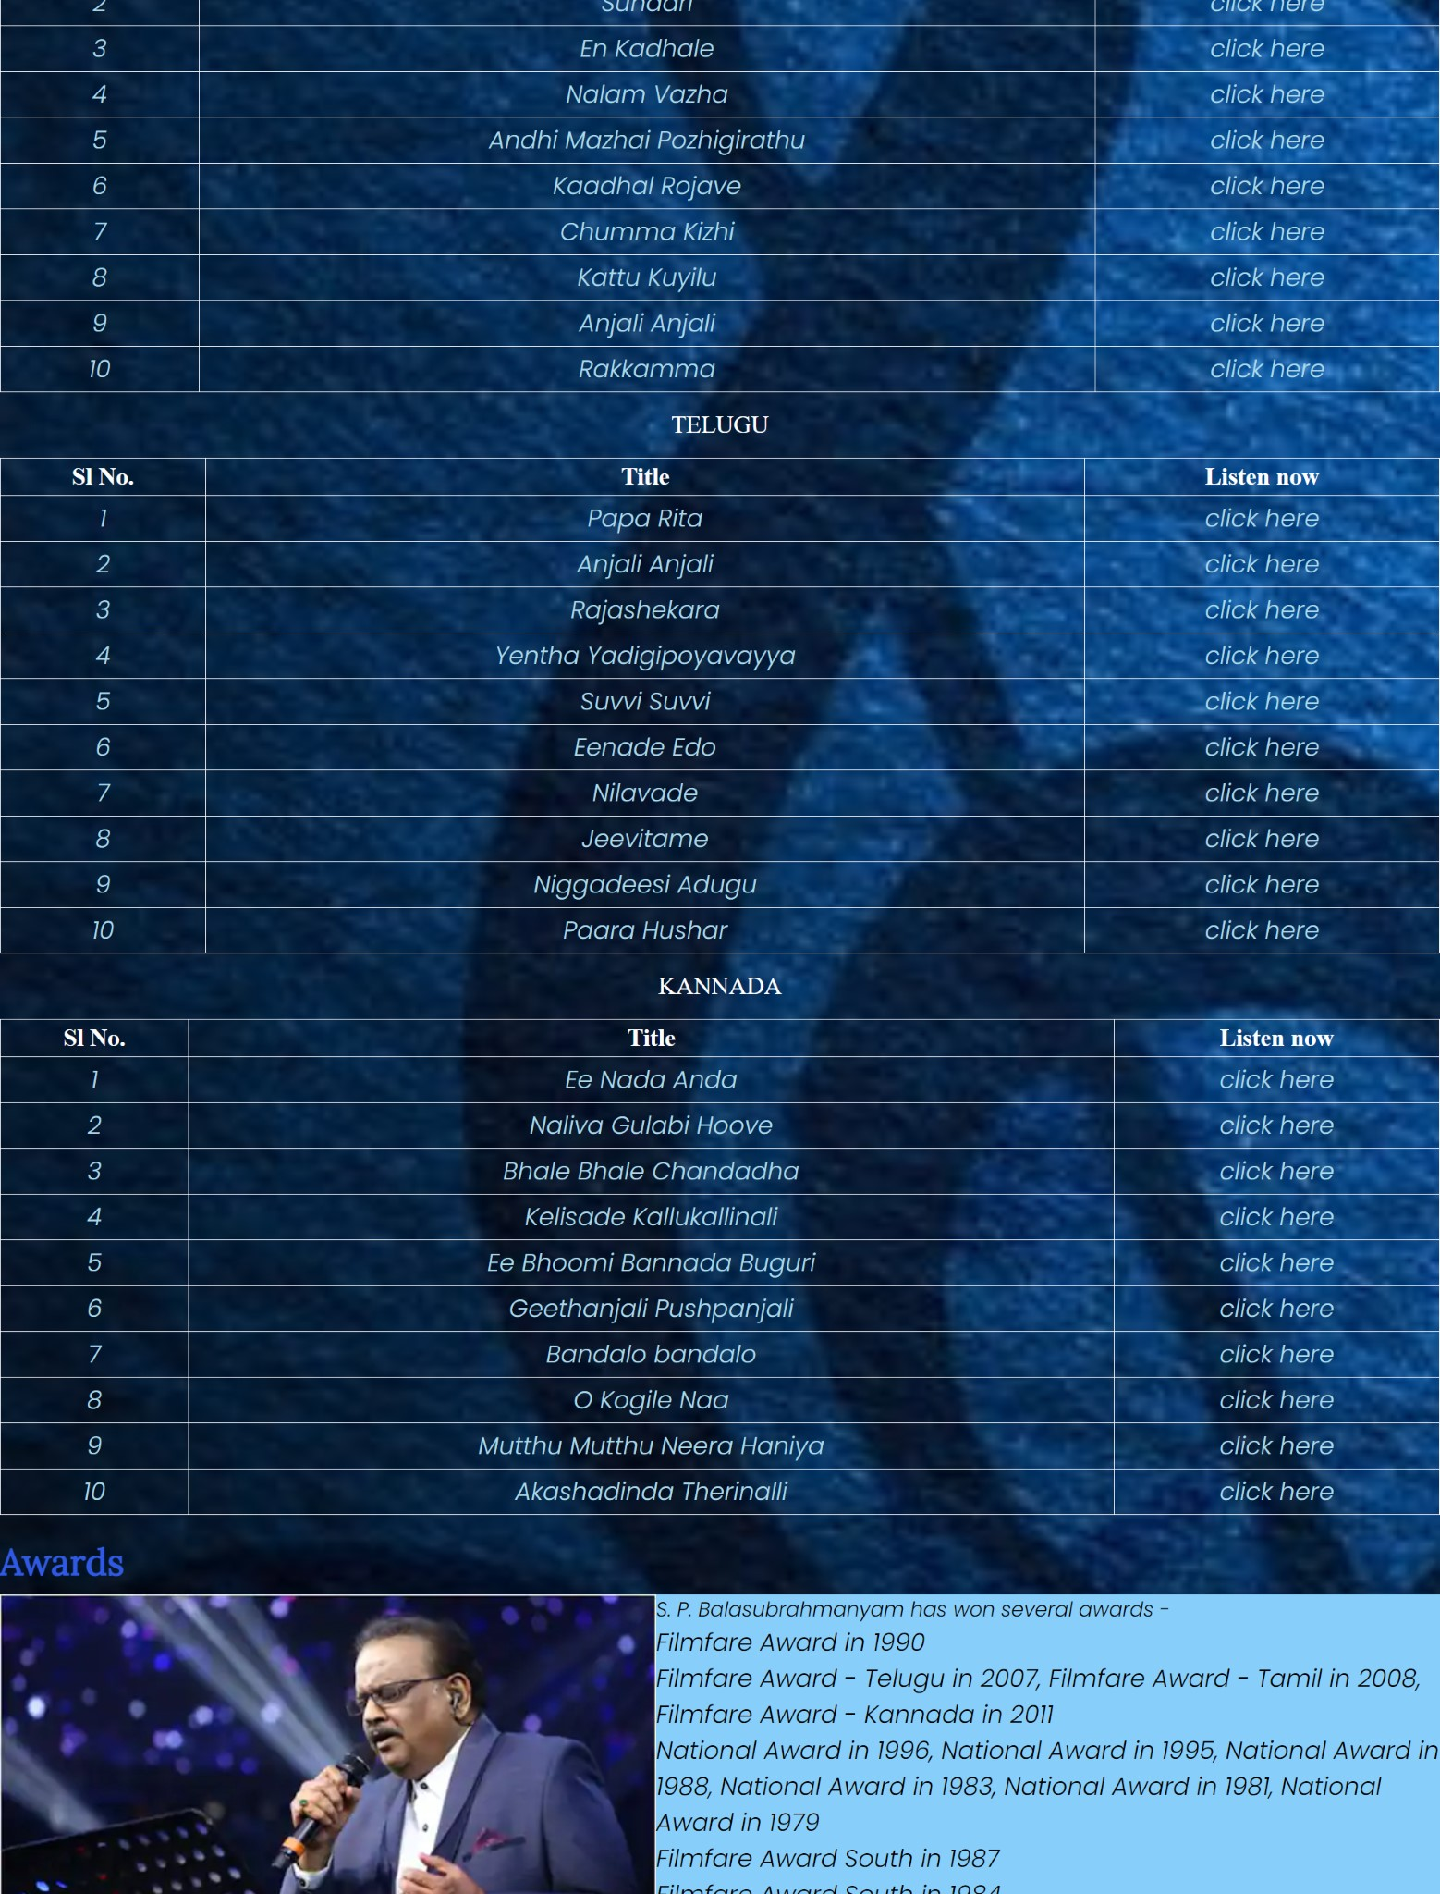

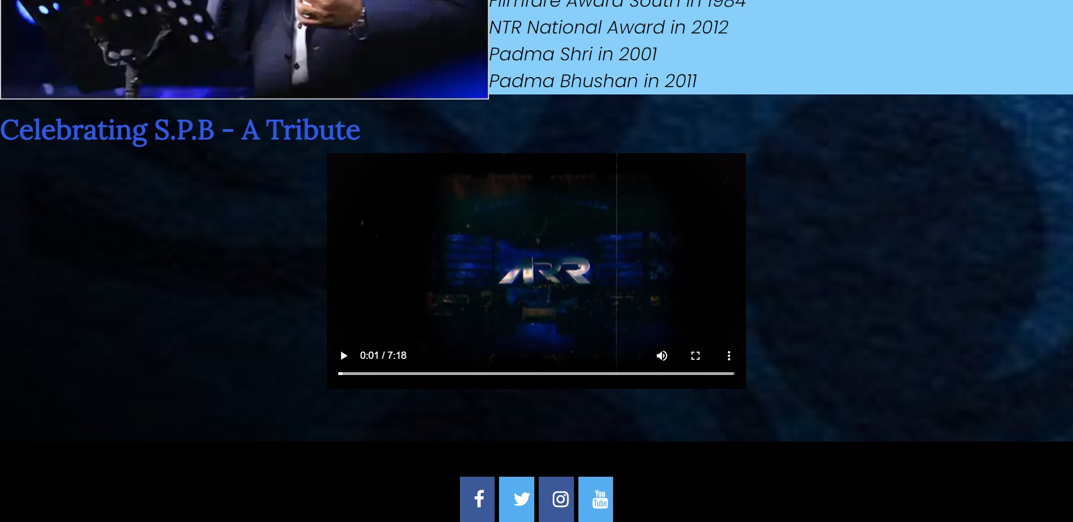

**LEARNING AND PROBLEMS FACED**

Learning-

The 1-month internship was a great experience. During the training phase which was about 7 sessions, I learnt a lot about version control system- git and Github, html- structure, elements, forms, tables, css- syntax, selectors, box model, units. During the project phase, I got to implement all that I learnt. It was totally interesting and enriched my skills on front end web development.

Problems Faced-

The entire internship was conducted online so there was not much direct interaction. More concepts could have been covered during the training phase.